# ECE 240 Prelab 5

Shobhit Chaudhry

s28chaud

20553474

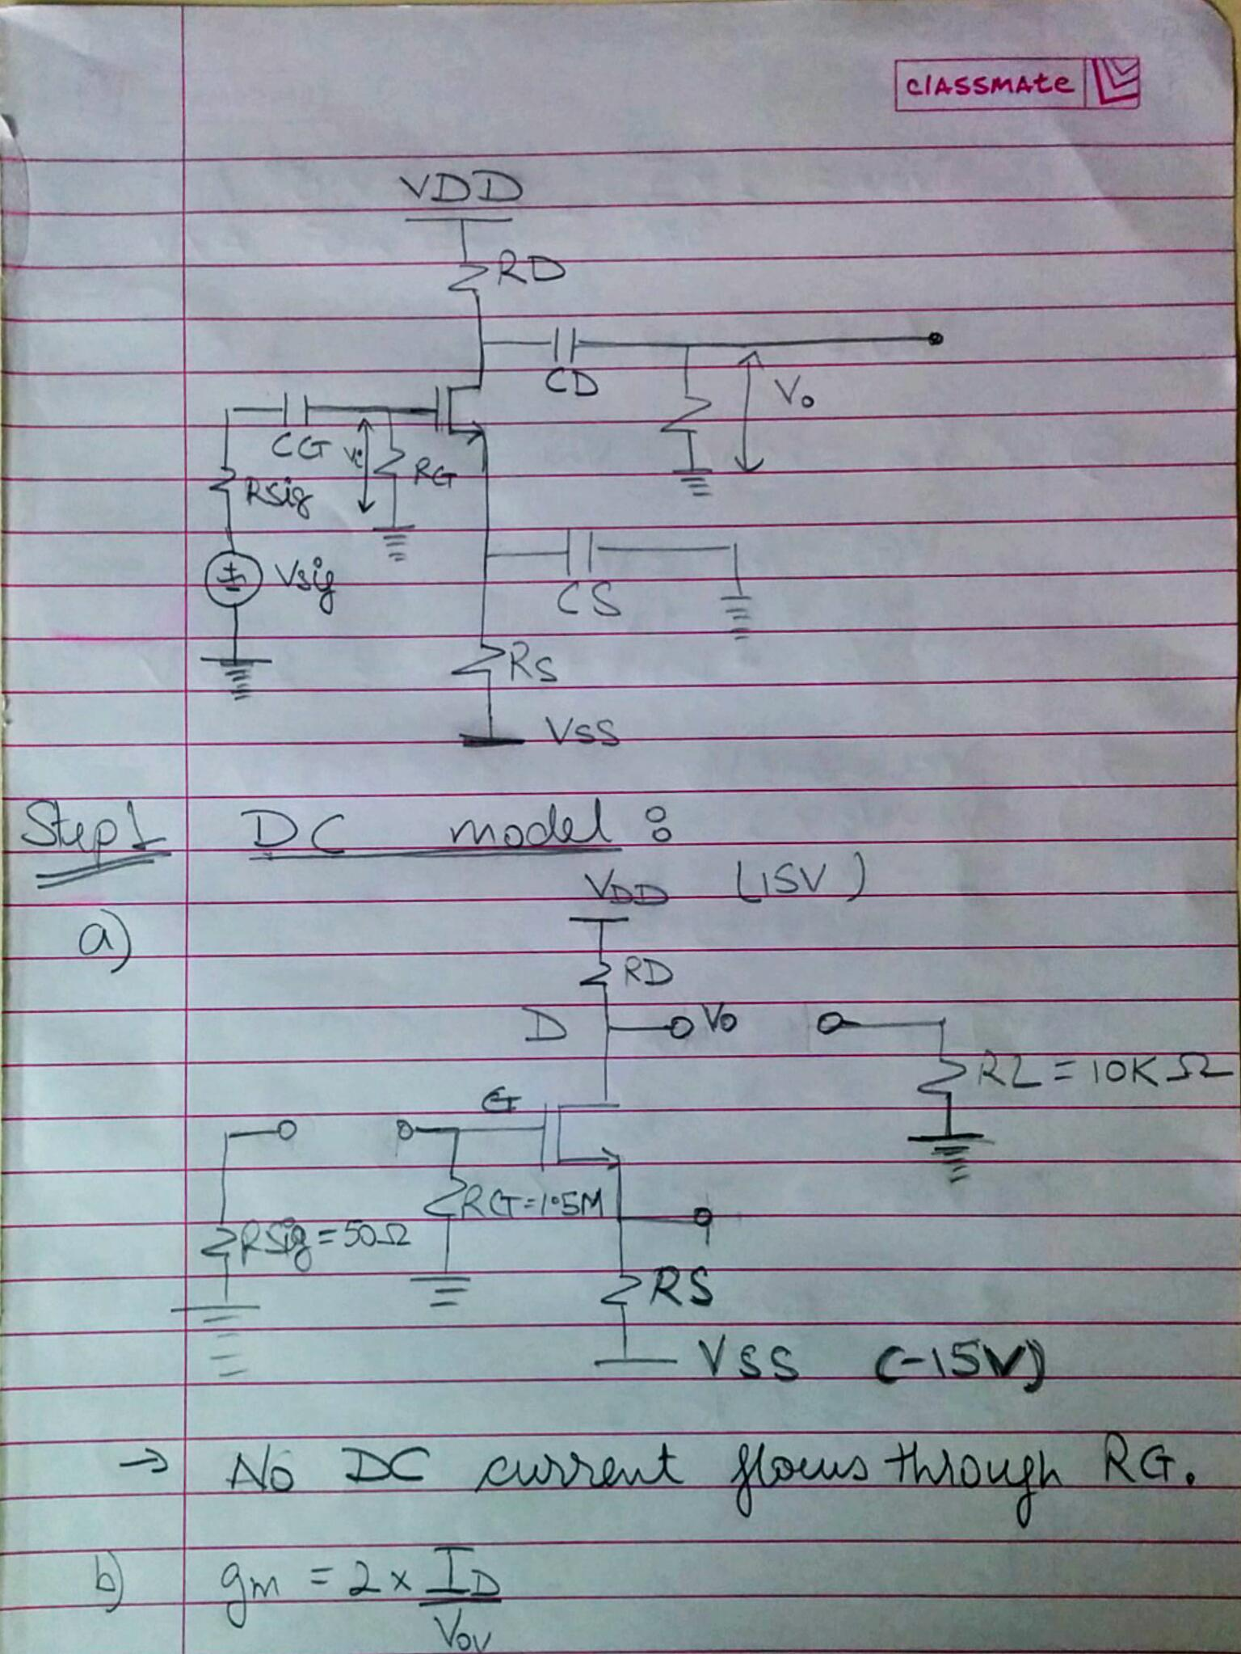

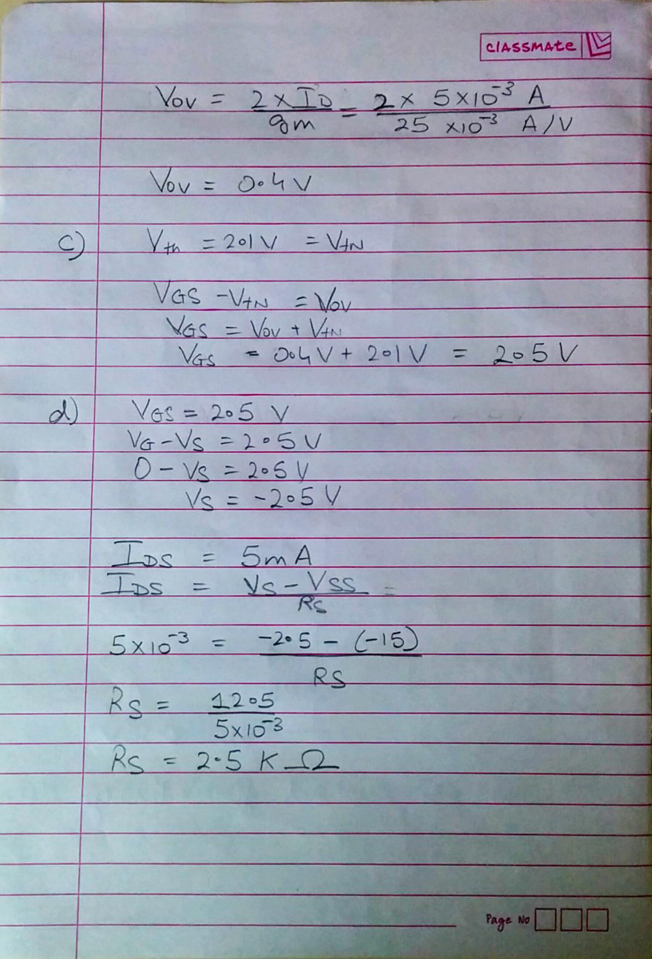

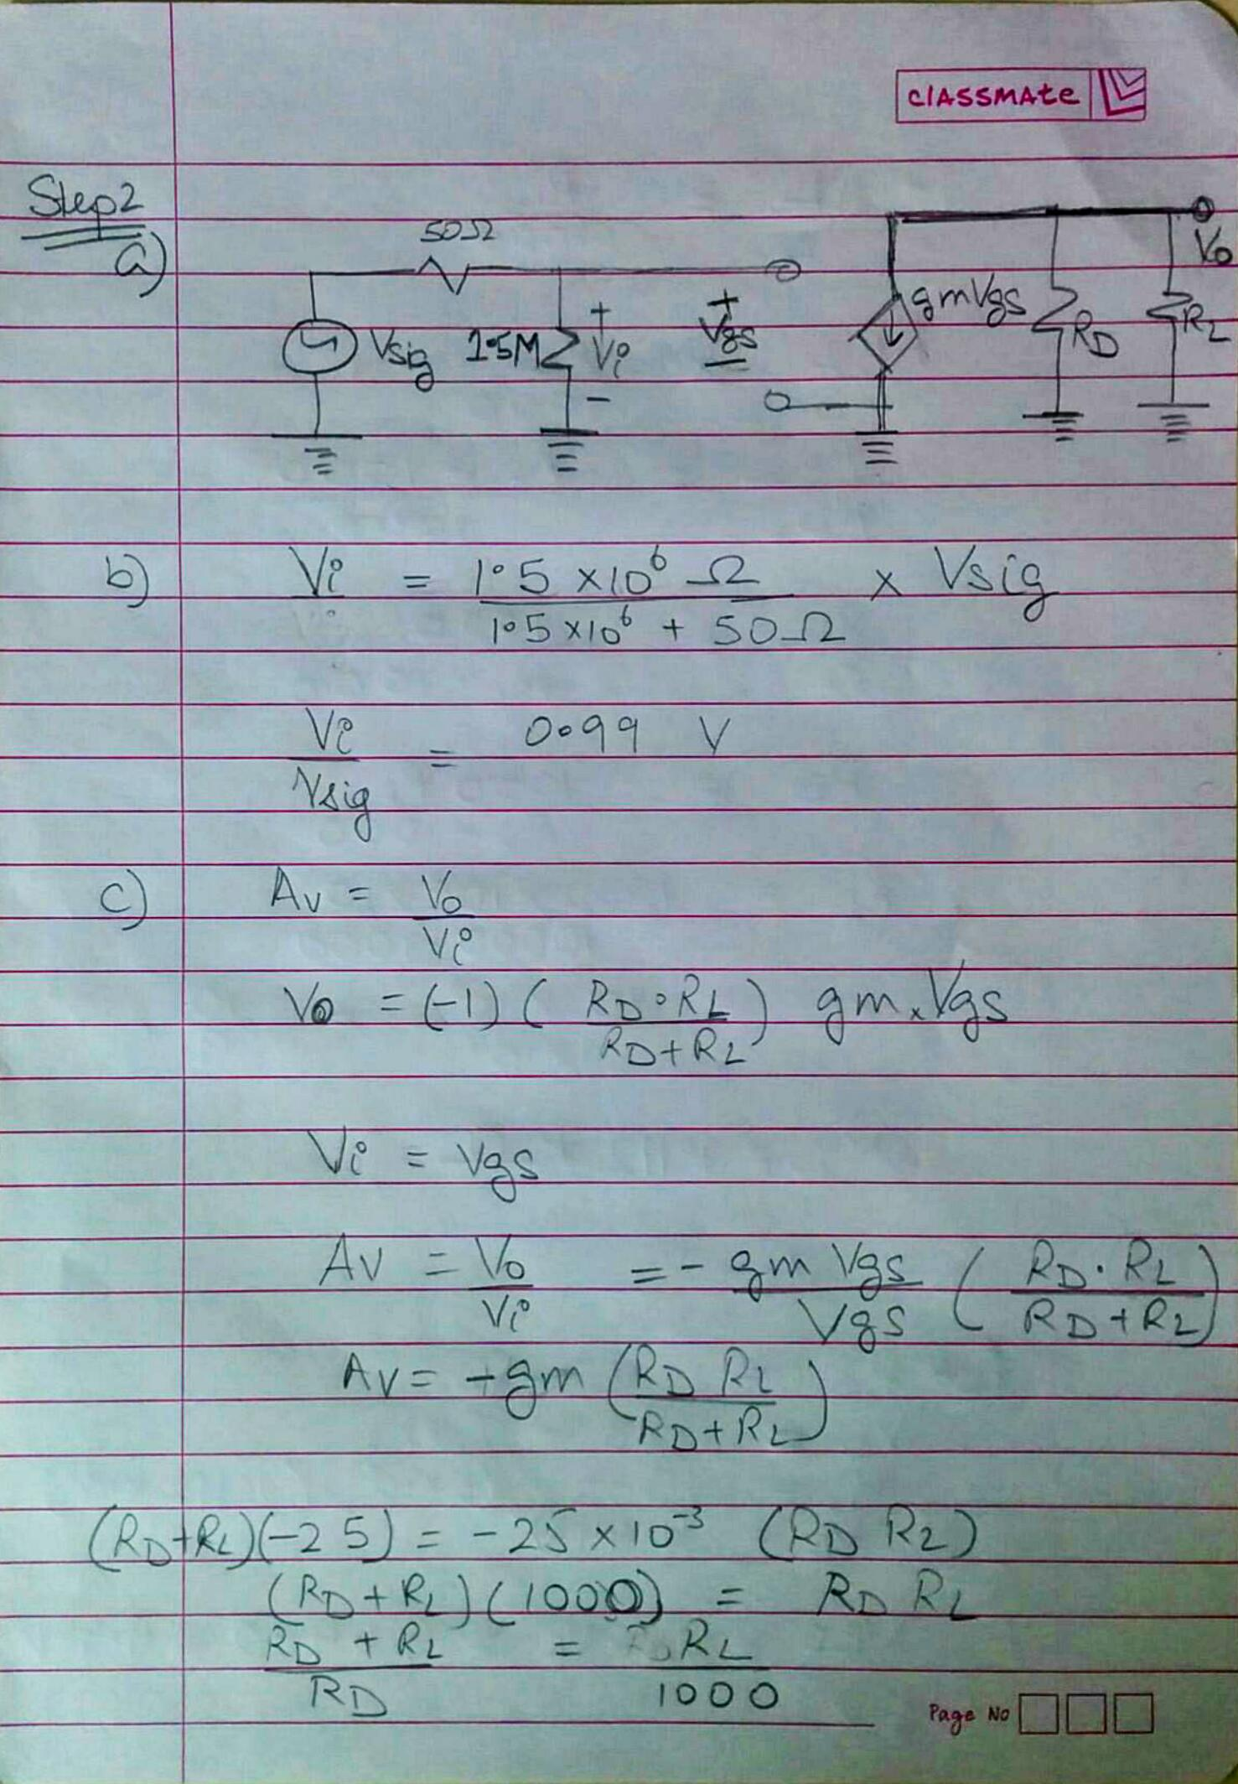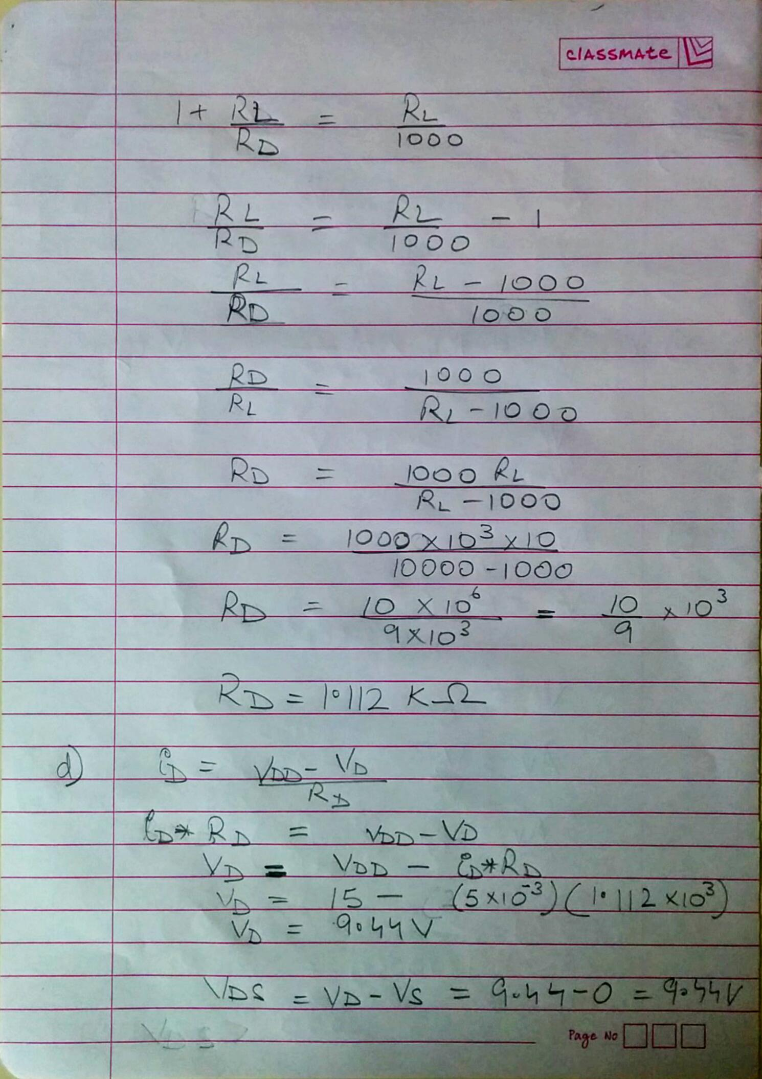

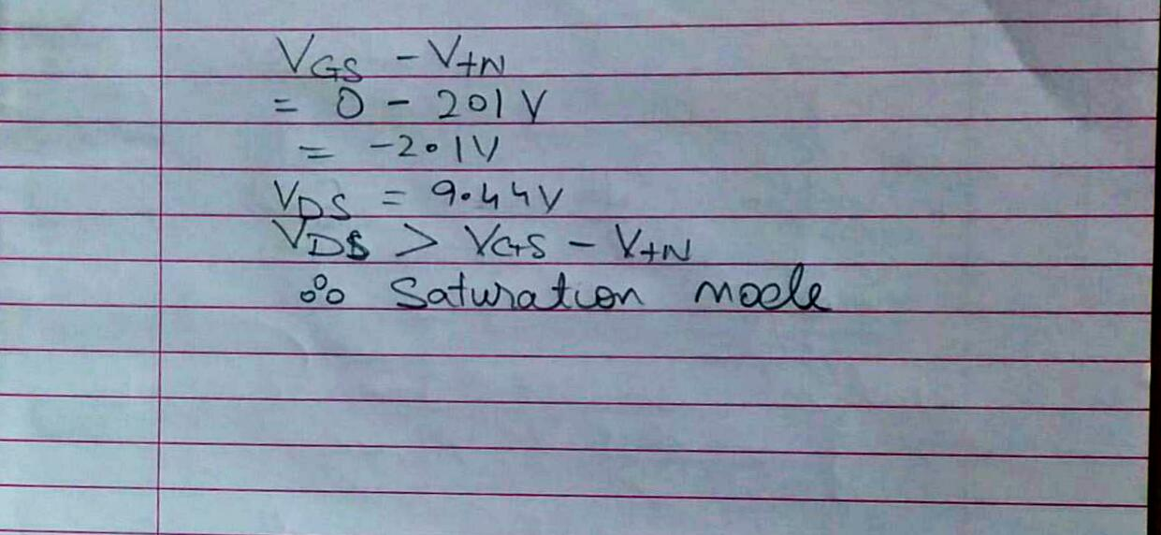

**Recorded Values from the simulation:**

VGS=2.113V

VDS=11.39V

IDS=5.154 mA

Av=|2.8876/0.09936| = 29.06 V/V

-3dB Lower: 1.03 KHz

-3dB Upper: 17.0782 MHz

